Are Smart Phones Spreading Faster than Any Technology in Human History? , 2012

<http://www.technologyreview.com/news/427787/are-smart-phones-spreading-faster-than-any-technology-in-human-history/>

Presented below is the U.S. market penetration achieved by nine technologies since 1876, the year Alexander Graham Bell patented the telephone. Penetration rates have been organized to show three phases of a technology’s spread: traction, maturity, and saturation.

Those technologies with “last mile” problems—bringing electricity cables or telephone wire to individual homes—appear to spread more slowly. It took almost a century for landline phones to reach saturation, or the point at which new demand falls off. Mobile phones, by contrast, achieved saturation in just 20 years. Smart phones are on track to halve that rate yet again, and tablets could move still faster, setting consecutive records for speed to market saturation in the United States.

Arriving in the wake of smart phones, tablets appear poised for even swifter adoption. After years of false starts, the tablet market sprang to life with the launch of Apple’s iPad in April 2010. Only 18 months later, tablet penetration among U.S. households had already hit 11 percent, according to a Google/Ipsos study. No other technology in this comparison has had such a fast start. Since that date, Amazon’s (essentially U.S.-only) Kindle Fire was introduced and sold at least five million units. In the last two quarters, Apple has also sold approximately 10 million more iPads in the U.S. market. As a result, the number of consumers in the U.S. who own a tablet computer now exceeds 13 percent just two years into the market’s existence.

It is difficult to conclude categorically from the available data that smart phones are spreading faster than any previous technology. Statistics are not always available globally, and not every technology is easily tracked. Also, because smart phones have not yet reached market saturation, as electricity and television have, the results are still coming in.

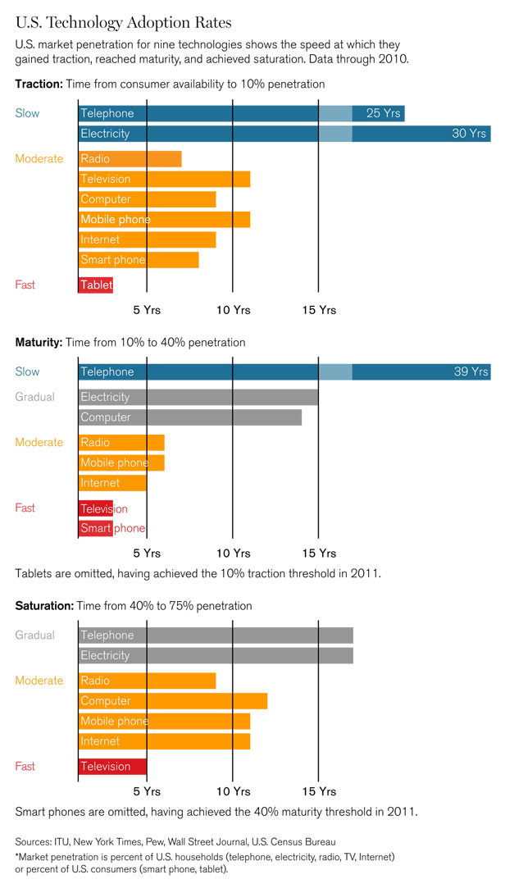

* Smart phone era began in America in 2002 with the BlackBerry
* Late 2006, quarter before iPhone announced, 715,000 smart phones were sold (6% of U.S. mobile phone sales)
* That changed when Apple’s iPhone sold 1.12 million units in its first full quarter of availability, despite prices starting at $399. Year over year, the market share of smart phones almost doubled, to 11 percent of U.S. mobile-phone sales. Now Nielsen reports that smart phones represent more than two-thirds of all U.S. mobile-phone sales. Nielsen also reports that 50 percent of all U.S. mobile-phone users—which equates to about 40 percent of the U.S. population—now use smart phones.
* These figures show that smart phones, after a relatively fast start, have also outpaced nearly any comparable technology in the leap to mainstream use. It took landline telephones about 45 years to get from 5 percent to 50 percent penetration among U.S. households, and mobile phones took around seven years to reach a similar proportion of consumers. Smart phones have gone from 5 percent to 40 percent in about four years, despite a recession. In the comparison shown, the only technology that moved as quickly to the U.S. mainstream was television between 1950 and 1953.
* How rapid is the spread of smart phones globally? For the rest of the world, historical adoption rates of technologies such as TV, radio, and the Internet aren’t as generally available. Further, in many regions, like Africa, smart phones are a recent phenomenon. That makes comparisons difficult. However, the unprecedented spread of simpler “feature” models of mobile phones in the developing world appears to put smart phones on a global fast track.
* In 1982, there were 4.6 billion people in the world, and not a single mobile-phone subscriber. Today, there are seven billion people in the world—and six billion mobile cellular-phone subscriptions. As with many technologies, the explosion began in the world’s most developed countries.
* Historically, a technology that reaches saturation in rich countries still spreads through the developing world only in correlation to each country’s state of development. In 1963, researchers famously mapped the GDP of nations against their “teledensity,” the prevalence of landline telephones. The data showed just this effect, which is known as the Jipp Curve.
* The mobile phone, however, is a landmark: over the last decade, the correlation between wealth and teledensity has been completely transformed.
* According to the International Telecommunications Union, in 2001 the developed world had six times as many mobile subscriptions per capita as the developing world. By 2011, that gap had collapsed to just 50 percent more phones per capita, and it continues to narrow substantially. Of the world’s six billion mobile-phone subscriptions, 73 percent are now in the developing world, even though those countries account for just 20 percent of the world’s GDP.
* Although the large majority of mobile phones in the world aren’t yet smart phones, the “dumb phones” have established the infrastructure, payment and distribution systems, and networks that are increasingly utilized by smart phones.
* The ITU claims that 90 percent of the world’s population is already covered by 2G networks, many of which can provide data services like Internet access via slower “2.5G” technologies such as EDGE and GPRS. The more modern 3G networks that have catalyzed the current smart-phone boom by providing richer, quicker mobile experiences have been expanding rapidly and now cover 45 percent of the world’s population, more than three billion people.

The cost of a smart phone and a service plan clearly remains an important barrier in poor nations, but it is a shrinking one. ARM Holdings’ Cortex A7 mobile CPU, expected in phones next year, is touted as a way to get smart phones to “the next billion people,” with a price-to-performance ratio five times that of 2010 models. Meanwhile, the Chinese firm Spreadtrum has already released a chip platform targeting sub-$50 Android smart phones. Despite plummeting device prices, accessible mobile data pricing will be critical as well.

* The inevitable trend is already clearly visible. According to IDC, smart phones accounted for 36 percent of global mobile-phone shipments in the first quarter of 2012, up from 25 percent a year earlier. If smart phones continue to gain at even this pace, “feature phones” will be largely a memory in another five years. It remains to be seen whether networks the world over can support such a rapid conversion to smart phones.
* According to Gartner, there are now at least 1.4 billion PCs in use worldwide. It remains to be seen whether tablets can maintain their record-setting pace. Mobile phones, on the other hand, are already selling more than 1.4 billion units every single year. One thing seems certain: squeezed between tablets and ever-smarter phones, the PC is seeing its reign as the world’s “personal” computer draw to a close.